## INDUSRIAL TRAINING

## (phase – 1)

## easyshiksha

## A PRESENTATION REPORT

## On

## DIGITAL MARKETING

## Submitted by

## 

## KARTHI C

## RA2011028010072

## in partial fullfillment for the award of the degree

## of

## 

## BACHELOR OF TECHONOLOGY

## 

## IN

## 

## CLOUD COMPUTING

## 

## 

## 

## BONAFIDE CERTIFICATE

## Certified that report on Digital marketing is proof of successful completion

## of industrial phase -1 programme undergone by KARTHI RA2011028010072

## In the company easyshiksha is located at jaipur during the period oct 1 2022

## to Oct 30 2022.

## 

## DATE : 26/11/2022 Signature of the

## Industrial traning incharge

## RUBRICS FOR EVALUTION

|  |  |  |  |
| --- | --- | --- | --- |
| S.NO | Marks split up | MAXIMUM MARKS | MARKS OBTAINED |
| 1 | Report Preparation | 80 |  |
| 2 | Quiz and viva | 20 |  |
|  | TOTAL | 100 |  |
|  | | | |

## 

## Signature of the Staff

## 

## TABLE OF AN CONTENT

|  |  |  |
| --- | --- | --- |
| SERIAL NO | TOPIC | PAGE NO |
| 1 | ABOUT THE COMPANY | 5 |
| 2 | DESCRIPITION OF TECHINICAL  WORK/TRANING | 8 |
| 3 | OUTCOMES | 19 |

## KARTHI C

## RA2011028010072

## ABOUT THE COMPANY

**Easyshiksha** an endeavour and a vision by the team of **HawksCode.** We aim to revolutionize the education sector, by working on the basic infrastructure and by developing smart skills to guide, help & improvise the knowledge.Easyshiksha helps in maintaining the top-notch intelligence quotient and e-learning base to everyone, with just a click. We initiated it in 2012 as a life hack to Students, Faculty Members, Educational & Digital Training Institutes, Universities, Online Distance Learning Schools, Coachings and parents.

We are a one-stop solution and sure-shot decision enhancing entity, with an easy & user-friendly interface. We provide certification courses for online programs which are valid and accepted across all industries and institutions.Our 5 modules include information for all the universities and colleges across the globe, E-learning Courses in 1000+ fields, Career helping guide based on IQ and aptitude, Regularly Updated daily test series for all Competitive exams, and Student Campus Ambassador Programs.

#### AWARDS AND RECOGNITION EASYSHIKSHA

EasyShiksha has been accredited by many prestigious, immensely valued and recognised authorities of the country. Some of them are as follows:

* Top-25 Start-Ups in Rajasthan Digifest 2017 by the honourable Chief Minister, Smt. Vasundhara Raje.
* Featured in "Top 20 EdTech Startup - 2018 in India"
* "India's 10 Best online Education providers, 2019"
* "Global Educational Influencers 2020".

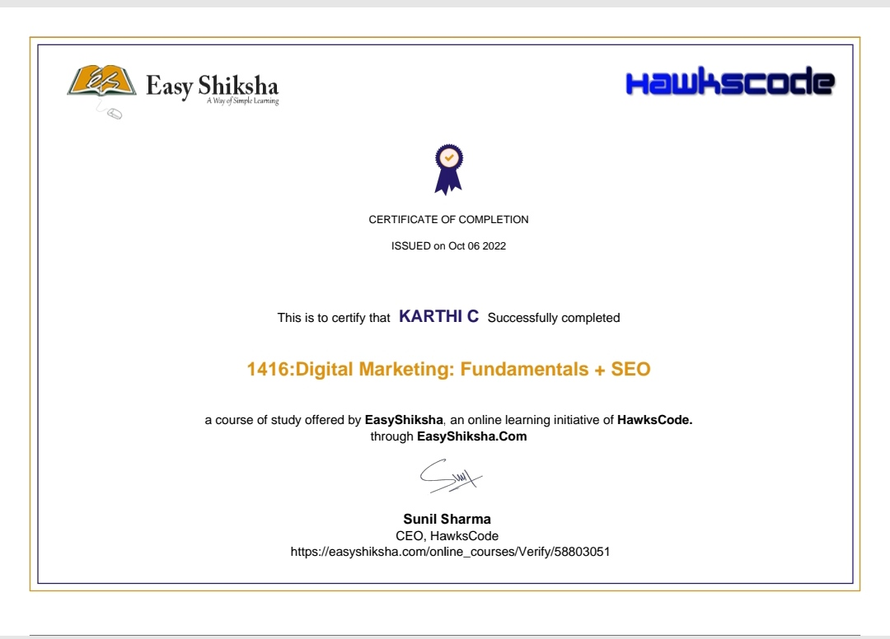

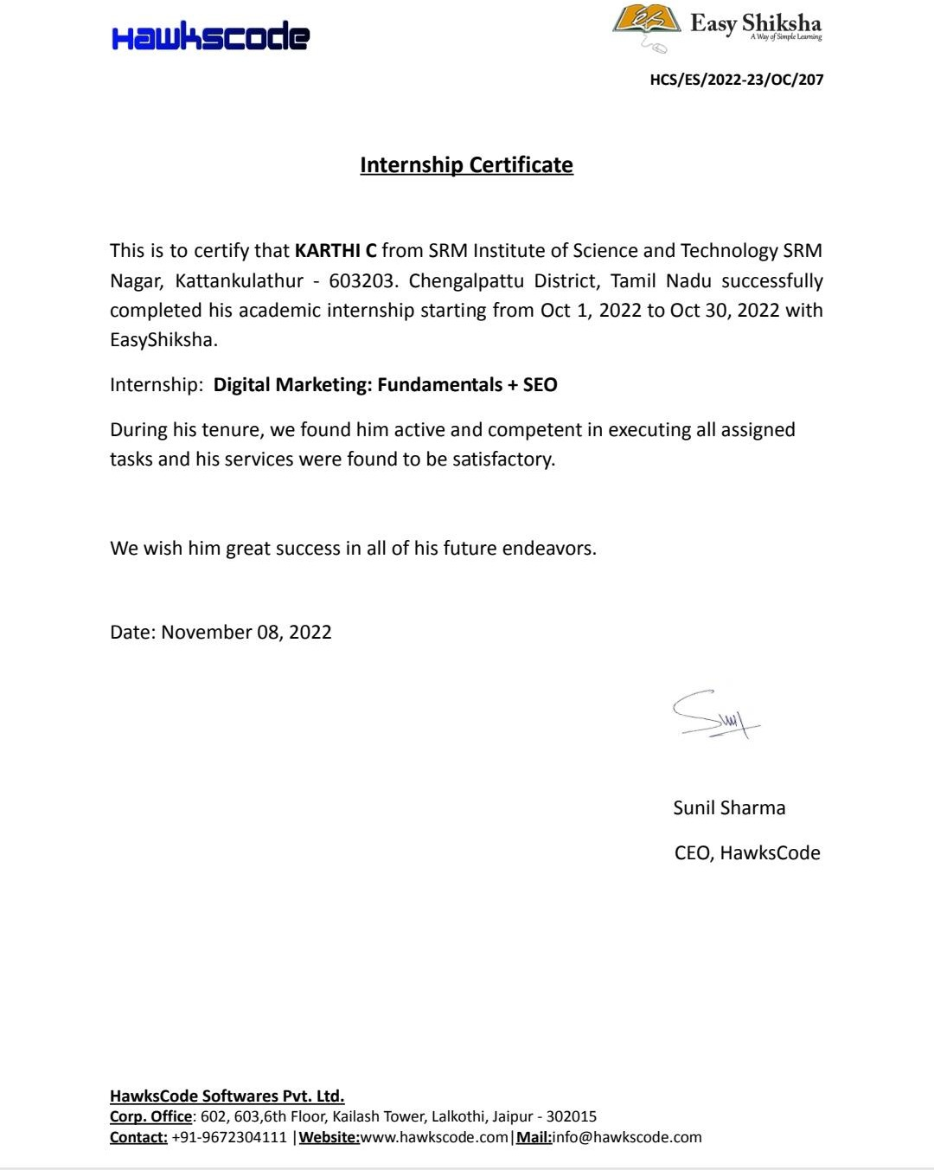

## DESCRIPITION OF TECHINICAL WORK/TRANING

## SEO(INTRODUCTION):

Search engine optimization (SEO) is the process of improving the quality and quantity of website traffic to a website or a web page from search engines. SEO targets unpaid traffic (known as "natural" or "organic" results) rather than direct traffic or paid traffic.

## ON PAGE SEO :

On-page SEO (also known as “on-site SEO”) is the practice of optimizing web page content for search engines and users. Common on-page SEO practices include optimizing title tags, content, internal links and URLs.

## OFF PAGE SEO:

This is different from off-page SEO, which is optimizing for signals that happen off of your website (for example, backlinks).

## SEO KEYWORD SEARCH:

## Step 1: Study your niche

Before you figure out what are the best keywords to optimize your page, it’s best that you start by diving deep to **learn more about your topic** or niche. It can give you **out-of-the-box ideas** and help discover angles to your marketing and SEO strategy that you might not have thought about before.

Here are a few ideas on **how to study your niche**:

Talk with your existing customers and get to know them better. Find out the terms that they use when describing your brand, company, product or service.

Try to think from the perspective of your potential customers. If you were to share the brand’s offering to a friend, how will you talk about it?

Get involved in your topic or niche’s online communities, like forums and social media networks. Read the discussions and find out any pain points that are mentioned regarding your niche.

# ****Step 2: Define your goals****

A plan needs to always begin by **defining the end goal**. But before that, you should ask important and introspective questions like:

Who are you?

What is your brand about?

What makes you special?

What is your website about?

What promises do you make on your website?

Once you have effectively answered these questions, then you need to specify [**what is your brand’s mission**](https://simplicable.com/new/brand-mission).

Do you want to increase the number of subscribers? Or do you have a sales target by a certain date?

It’s important to define your goal because it will **provide a direction for your SEO strategy** and plan. The search terms that you will eventually use should be aligned to your goals, ideally segmented into different [**content marketing funnels**](https://moz.com/beginners-guide-to-content-marketing/marketing-funnel). Your goals will also inform the purpose of your SEO copywriting and content.

Write down your goals. Draw charts. Document them. These will provide the **framework and direction** needed for your top-level content and online marketing strategy.

## ****Step 3: Make a list of relevant topics****

Based on your the main category of your brand and the goals you aim to achieve, break it down to **smaller topic buckets**. Make a list of all the **topics related to your brand** that you want to rank on Google.

For example, if you’re an [**FMCG**](https://en.wikipedia.org/wiki/Fast-moving_consumer_goods) brand specializing in men’s personal care products, some topics that are related to your brand can be:

men’s facial wash

antiperspirant deodorant

male pattern baldness

They need to be topics that are **important to your business** and related to your [**buyer personas**](https://digitalmarketinginstitute.com/blog/2017-4-27-the-beginners-guide-to-defining-buyer-personas). Think about what type of topics will your target audience search for on Google? These topic buckets can then later be broken down to keywords that are related to those topics.

## ****Step 4: Create a list of seed keywords****

Now that you’ve broken down your main category to different buckets of sub-topics, you can start creating a list of seed keywords. These keywords need to be **related to your various topics**, and more importantly, are terms that your **target audience might be searching** on Google.

Seed keywords, or focus keywords, are important as they will become the foundation of your keyword research. They define your niche and identify your competitors.

If you’re wondering **how to find** the seed or focus keywords of your brand or product, it’s actually a lot easier than you think. All you need to do is describe your offering as simple as possible and brainstorm how other people might search for it on Google.

## ****Step 5: Use good keyword research tools****

You might assume, “shouldn’t keyword research begin with using a keyword tool?” There’s no right or wrong answer there, to be honest. But there is an obvious advantage to researching search terms from your brand or business perspective **first and foremost**.

It avoids you from getting too bogged down with keywords and helps you gain a wider perspective for your content and SEO strategy.

Once you have identified your goals, topics, and a list of seed keywords, it’s time to use keyword research tools to **further refine your search terms**.

One option is to use [**Google Keyword Planner**](https://adwords.google.com/ko/KeywordPlanner/Home). Unfortunately, Google only gives approximated search volumes. Instead, you can use a tool like [**Keyword Tool**](https://keywordtool.io/). It will give you a lot more details and help you **narrow down** on the right direction for your search terms. On top of that, it can also give **additional ideas** on related keywords.

All you need to do is type in the topic (or seed keyword) into the search box and it will give you a list of alternative keywords, including those that contain **prepositions and questions**:

## ****Step 6: Study the search intent:****

Plugging in high-volume keywords to bump up rankings for a page used to work pretty easily. But it’s **not so simple anymore** these days. Today, Google’s machine learning search algorithms **compare search terms with user queries** to learn about search intent.

[**Search intent**](https://blog.alexa.com/marketing-research/search-intent/) is defined as the intent or **reason behind** why people search for a specific term. There are many driving factors behind people’s search habits, such as:

Why are they searching?

Are they searching because they have a question and want an answer to that question?

Are they searching for a specific website?

Are they searching because they want to buy something?

Try to put yourself in your target audience’s shoes. Why would they search for your topic? How will they key in the terms? Are they looking to buy something? Or are they looking for a service to solve a specific problem?

Once you have a good idea of the search intent behind potential readers or customers, you will be able to use it to **fine-tune your keyword research**. Getting a list of high-volume keywords related to your brand or topic is great. But finding keywords that **directly match** your target audience’s search intent is even better.

## ****Step 7: Identify long tail keywords****

Seed keywords are often shorter search terms that are closely related to your brand’s main topic or category. [**Long tail keywords**](https://keywordtool.io/long-tail-keywords), on the other hand, are **more descriptive** and often related to your brand’s smaller buckets of sub-topics. Matching your target audience’s search intent to long tail keywords is far easier compared to seed keywords.

For example, if your website published content about golf equipment reviews, using long tail keywords like “what is the best 9 iron golf club” will attract a **more relevant audience** compared to the seed keyword “golf club.”

Long tail keywords usually get fewer clicks, but since they are focused on a specific topic or product, they often [**get a higher conversion rate**](https://www.wordstream.com/long-tail-keywords).

## ****Step 8: Find out about your competitors****

Doing keyword research on Google about your brand alone is not nearly enough. You also need to be aware of **what your competitors are doing**. The better you understand the content landscape of your industry, the better it will be for your SEO.

Understanding the competitiveness of different keywords will also allow you to identify search terms that might be **too difficult to rank**. But most importantly, you will be able to find [**keyword opportunity gaps**](https://moz.com/blog/finding-gaps-and-opportunities-step-3-of-the-8step-seo-strategy). These opportunities occur when you find related keywords that are related to your brand or industry with **low to medium competition level**.

To find these keyword opportunities, you can perform a **keyword search on your competitors**. The paid version of [**Keyword Tool Pro**](https://keywordtool.io/pro) has a competitor analysis function that does exactly that. Key in the URL of your competitor into the search box and the results will show all the keywords that the page ranks for.

Once you’ve gone through these steps, you should have enough insights to **craft a good content and SEO strategy**. You would also have gotten adequate data for SEO copywriting for your content.

Whether you’re running a content-focused blog, a small business, or a brand marketer, you will need **keyword research to kick-start** your content and marketing activities.

Doing keyword research can be a tedious and time-consuming task. But more often than not, it pays off handsomely in the long run.

## ****Steps to Run Facebook Ad Campaign****

## ****Step 1: Log in to Facebook Account****

Simply log in to Fb Account, then click on “Create on Ad” in the dropdown menu next to the home button. It will take you to “Advertise on Facebook Page”.

## ****Step 2: Choose Objective****

You need to define the KPIs for your Facebook Adverts. Facebook gives you the freedom to select from a wide range of specific business goals. Some of them are:

* App Engagement
* App Install
* Post Boosts
* Offer Claims
* Page Likes
* Website Conversions
* Video Views
* Event Responses

## ****Step 3: Create Your Advert Account****

Enter your account information and fill necessary information such as account country, time zone and currency. All your advertising billing and data will be recorded in the currency and time zone of your choice.

## ****Step 4: Define Your Audience****

You need to experiment with several targeting option available here at Facebook Adverts. These experiments will help you in finalizing the audience that best fits your business goals.

Facebook targeting tool takes into consideration all the major prospects so that your ad gets trigger to the most relevant audience.You can choose between a specific audience (age, location, gender, language etc.) or a broad audience. If you driving traffic to your website is the primary objective, then focus on audiences who can become potential customers. Otherwise, you can select broad audience if you just want to build general brand awareness.

## ****Step 5: Set Placement****

Select apps and services offered by Facebook, where you want to run your Facebook Adverts. The available placements are:

* Facebook feeds (mobile and desktop)
* Facebook right-hand column
* Instagram
* Audience Network

[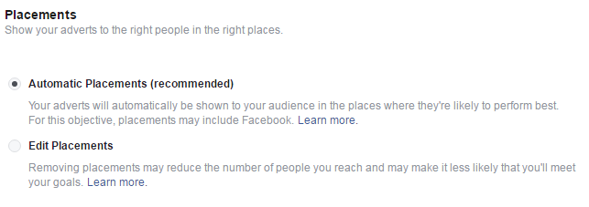](https://blog.payumoney.com/wp-content/uploads/2016/12/Step-5.png)

We recommend you to select “Automatic Placements” as it will automatically show your ad to audience in the place likely to perform best.

## ****Step 6: Allocate Budget****

Facebook allows you to choose either a daily budget or a life time budget. Daily budget will run your ad continuously throughout the day. Daily budget for an ad set is $1.00 and must be at least 2X your CPC. However if you want to run your ad campaign for a specific period of time, then go for Lifetime budget option.

[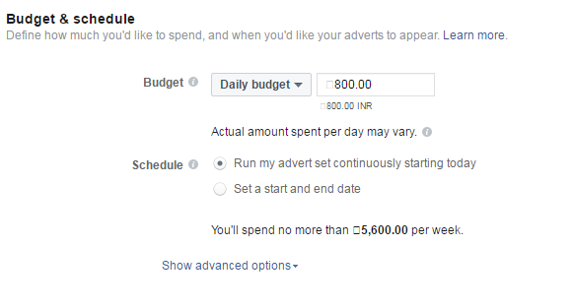](https://blog.payumoney.com/wp-content/uploads/2016/12/Step-6.png)

## ****Step 7: Choose the Format of Your Ad****

Choose how you would like your advert to look.  You can either select single image ad or a multi-image image (Carousel).  A carousel is three to five scrolling images that comes with no extra cost.

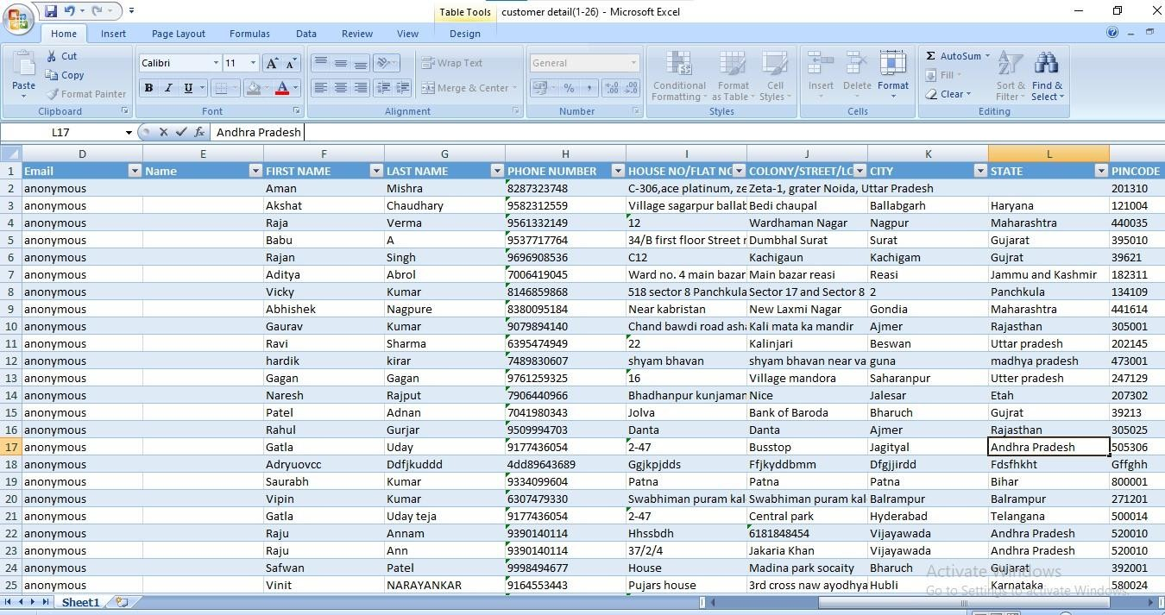

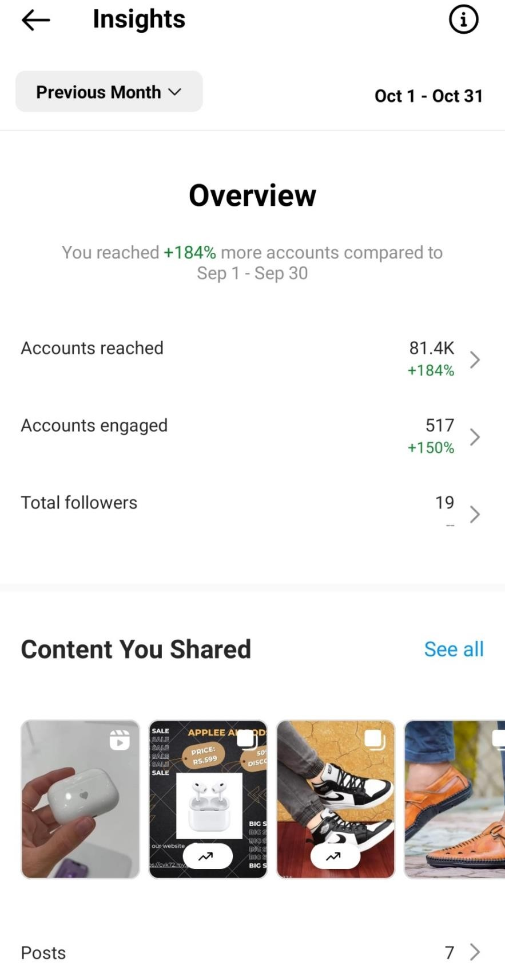

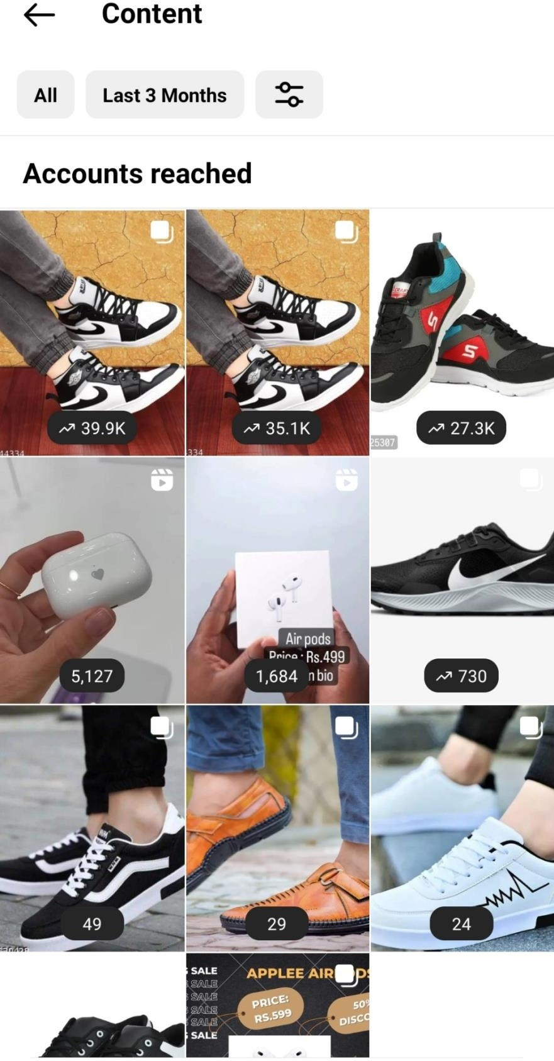

## OUTCOMES:

* On page seo and off page seo
* Running ads on instagram and facebook

## OUTCOMES:

* On page seo and off page seo
* Running ads on instagram and facebook